**Let’s get started!**

**What is your research discipline? What is your area of interest or specialism?**



*SAGE Journals* is where you will go to access cutting-edge, impactful research published by SAGE and subscribed to via your library.

Use this platform discovery map to learn more about the platform in relation to your research needs. There is a model completed overleaf: use this as an example to guide you as you complete your own.

You can explore more of our training resources [**here**](https://uk.sagepub.com/en-gb/eur/training-resource-centre).

**Create a profile (top-right of page) so that you can save this search, and even set up email alerts when new articles matching these search parameters are published.**

**Open one of the journals which sounds interesting and relevant to you. Navigate to the current issue; when was this published?**

**Now run a search for your specific area of interest within this journal. How many results do you see?**

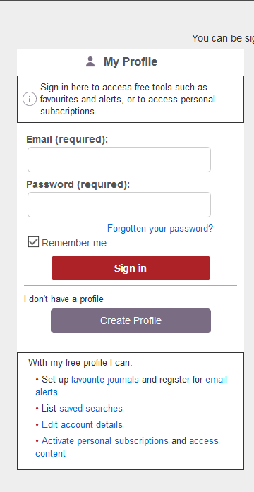

**Select the ‘Advanced’ search option at the top of the page. Try a more refined search, perhaps including Boolean operators (AND, OR and NOT), and limiting your publication dates. You might also like to apply the ‘Open access’ filter.**

**How many results do you see?**

**You may like to conclude by saving this search for future use as well.**

**Start by browsing our journals A-Z and make a note of three journals related to your discipline.**



Platform discovery map: example

**Let’s get started!**

**What is your research discipline? What is your area of interest or specialism?**

*Psychology; effects of spirituality on psychological functioning*

**Start by browsing our journals A-Z and make a note of three journals related to your discipline.**

*1) Archive for the Psychology of Religion – 2) Culture and Psychology – 3) Journal of Health Psychology*

**Open one of the journals which sounds interesting and relevant to you. Navigate to the current issue; when was this published?**

*August 2019 (Journal of Health Psychology)*

**Now run a search for your specific area of interest within this journal. How many results do you see?**

*59 (‘meditation AND anxiety’)*



**Create a profile (top-right of page) so that you can save this search, and even set up email alerts when new articles matching these search parameters are published.**

You can explore more of our training resources [**here**](https://uk.sagepub.com/en-gb/eur/training-resource-centre).

**Select the ‘Advanced’ search option at the top of the page. Try a more refined search, perhaps including Boolean operators (AND, OR and NOT), and limiting your publication dates. You might also like to apply the ‘Open access’ filter.**

**How many results do you see?**

*68*

**You may like to conclude by saving this search for future use as well.**